# 

# 

# **TABLE OF CONTENT:**

**1. Team Profile:-------------------------------------------------------------------------------------------------3 - 5**

**Team Name—----------------------------------------------------------------------------------------------3**

**Team members information —-------------------------------------------------------------------------3 - 4**

**Team Profile—---------------------------------------------------------------------------------------------4**

**Ideal job—--------------------------------------------------------------------------------------------------4 - 5**

**2. IT Jobs—------------------------------------------------------------------------------------------------------5 - 7**

**Day in a life of a video game—--------------------------------------------------------------------------------5 - 7**

**3. IT Technologies:--------------------------------------------------------------------------------------------8 - 16**

**Autonomous Vehicles/Self-driving Vehicles:--------------------------------------------------------8 - 9**

**Cyber Security and Privacy:---------------------------------------------------------------------------9 - 11**

**Natural language processing and chatterbots—---------------------------------------------------11 - 13**

**Artificial intelligence and Machine Learning—---------------------------------------------------13 - 14**

**Robots—---------------------------------------------------------------------------------------------------15 - 16**

**4. Project Ideas:-----------------------------------------------------------------------------------------------17 - 19**

**Overview—------------------------------------------------------------------------------------------------17**

**Motivation—----------------------------------------------------------------------------------------------17**

**Description—---------------------------------------------------------------------------------------------17 - 18**

**Tools and Technology—--------------------------------------------------------------------------------18**

**Skills required—----------------------------------------------------------------------------------------18**

**Outcome—-----------------------------------------------------------------------------------------------19**

**5. Feedback:---------------------------------------------------------------------------------------------------19 - 20**

**References & Appendix:----------------------------------------------------------------------------------20 - 35**

# **1. Team Profile**

## **Team Name: Octavius Concern**

## **Team member information:**

Le Huy Hoang, student ID: s4026730, he achieved a Bronze medal in LiChO in 2022 and is a former student of UK Academy Ba ria, currently an undergraduate student of the Information Technology program of the School of Science, Engineering and Technology at RMIT Vietnam. He loves to read all kinds of books and do physical / fitness training. He is also a philomath. He was inspired by his uncle, who led him to the IT road, and he is aiming to become a cyber security expert. He used to study Python and HTML in his club period while studying at UK Academy Baria as programming languages and is currently studying C, CSS and Java.

Nguyen Luong Le Bao, student ID: s3636073, currently studying in Bachelor of Language Major at RMIT Vietnam. He is an avid sci-fi and fantasy book reader and enjoys watching and playing various types of simulated and strategy games. Most of the reasons he got interested in IT actually had to do with curiosity about game developments and simulation technologies, such as the task of game programming, in-game AI developments, procedurally generated environments as well as various applications regarding simulations of environments and objects and how they can be applied to real-life scenarios.

Do Le Minh Quan, student ID: s4032589, he loves listening to music and playing video games. That led to his curiosity about technology starting when he was in secondary school. He loves deep-diving into how a computer’s components communicate with each other and create a useful working device. Soon enough, when he continued his study path in high school, he was inspired by his friends who had the same hobby about technology, so they began with small projects and basic coding. He is currently studying for an Information Technology Bachelor at RMIT with various languages, for instance, Java and web development languages like HTML, CSS and Javascript.

Nguyen Viet Hoang Dan, student ID: s4053659, he likes to go to the gym, making humorous content whenever he has free time. He is interested in developing games, inspired by his experiences with games made by independent game developers, especially how they published such detailed games while needing more financial and workforce resources like big enterprises. He used to have a period of studying the Python programming language. Currently, he is learning and adapting C++ and C#, concentrating on the Artificial Intelligence and Software Development section.

Tram Anh Tuan, student ID is s4075376. He is studying for a Bachelor of Information Technology at RMIT Vietnam. He enjoys going to the gym and reading different book genres in his leisure time. He is also a member of the football club. He is interested in exploring and fixing computer components and likes solving problems. He plans to work as a Technical Lead. He is currently self-studying Python and C++.

## **Team Profile:**

Le Huy Hoang his personality can be known as developing over time, which means he may improve his level faster over time, which will benefit not only himself but also the group. The more information he accesses, the better ideas he might come to convert ideas to better ones.

Nguyen Luong Le Bao is a personnel with a creative imagination and also an adapting personnel who can take out the opportunity when it comes across. Therefore, he can solve the missing gaps in each member's idea whenever they are missing crucial elements. Moreover, he is eager to conduct searches about certain problems, which will push the team project progress faster.

Do Le Minh Quan is the best at listening to what people say in the team and then typically thinking thoughtfully and cautiously about it before debating face to face about it. Moreover, he always rethinks about it over and over in his mind if the ideas he presented make him feel unsatisfactory and then present them to the group. Although he is not good at social skills, his ideas help the team redevelop them into the one that is more fit or needed by his team.

Nguyen Viet Hoang Dan likes to care what people think and to assist people around him when he sees them struggling. Although he may not be good at socialising, he thinks deeply about every word he speaks to the opponents to understand what may be best for them in cases. Partners appreciate him trying to help them and will likely push the team's morale to the highest to overcome the situation.

Tram Anh Tuan loves to take action and develop his colleagues' ideas into practical products. Because of his mastery of tools and equipment, he tends to create outstanding programs based on these ideas and then presents them to the team. Which sometimes completes the innovation tasks on his own.

## **Ideal Jobs:**

In our group, we found that there are 4 different jobs which are Game Developers, Project Manager, Cyber Security, Technical Support Engineer. Below are the diagram for comparison between jobs to each others, it will include what common do those jobs shared to each other and what are the differences:

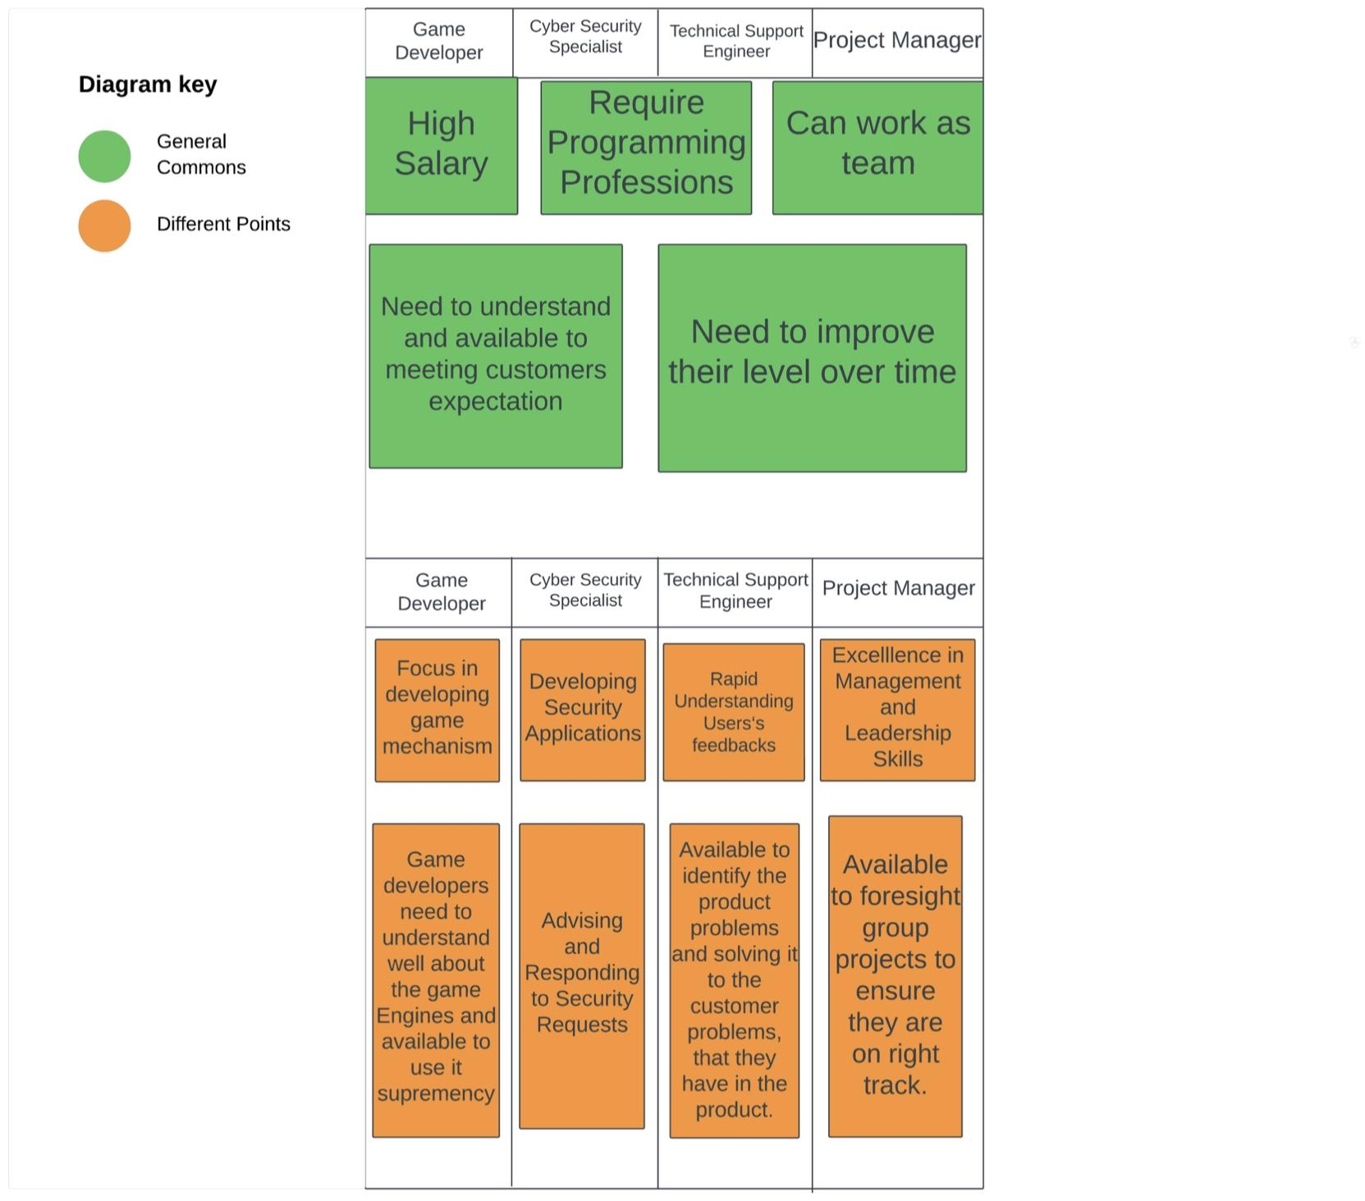

# 

# **2. IT Jobs**

## **Day in a life of a video game programmer:**

Video link: <https://www.youtube.com/watch?v=e_TxH59MclA>

The video in question is an interview of a Japanese game programmer named Masa who works for Bandai Namco Studio in Tokyo. It also highlights the average daily interactions and activities of his profession.

**What kind of work is done by the IT professional?**

As a game programmer, Masa work involved working for hours at the company’s office in Tokyo from the morning to the evening everyday. All of his task is about coding. Everyday, the first thing Masa did at work is checking the emails and company’s internal social networks for updates while having a quick light meal. Because of the nature of his job, the company facility also has a library of games and various gaming devices, from consoles, PCs to VR headsets for testing the gameplay and addressing various technical issues before public release. Most of his important work as a programmer involved coding for the game’s interface, control, animation, environment and ingame mechanics.

**What kinds of people does the IT professional interact with? Are they other IT professionals? Clients? Investors? The general public?**

The work of this game programmer also involved interactions with his fellow workers. In this video, Masa’s fellow colleague is called a “Douki”, an employee who also joined the company around the same time as him. This is because companies in Japan tend to do annual mass hiring for newly graduated college students. Also during this lunch break, whenever he finished a meal, he usually spent his time playing some of the arcade games in the office like the PacMan arcade box in his company. Masa is a game programmer of a larger development team, which usually has around 200 people and the development time of a video game from a big company like this typically took 5 years.

Other people he interacted with are the members of the development team that he was assigned to as part of his job. In a Japanese game development company with a large employee size, offices tend to be divided between different teams for different departments. As part of Masa works, he also has a scrum meeting daily for 30 minutes with other project managers and developers to review his programming and provide feedback for his works on a daily basis and share what needs to be done in the future. These are usually done by the use of digital softwares to display all the tasks onscreen during the meeting. On occasion, he also talks with people from the Finance department to discuss issues with the expenses.

**Where game programmers spent their time:**

As part of a larger game development team and an employee of one of the largest Game development and publisher in Japan Bandai Namco, Masa mostly spent the time of his daily work at the office from the morning to evening for at least 8 hours of work. From 12:00 PM to 1:00 PM, Masa and his fellow workers would often go to lunch with one another before resuming their works, this usually came in the form of a food trucks that arrived at the front of the office entrance everyday, although sometimes he also went to local convenient stores to buy food for lunch if he have little time for the break.

Aside from the usual daily works, Masa also spent a bit of his time in the early noon (around 2:30PM) to take a quick nap. This is because daily work in game development can also be quite exhausting, which is why companies in Japan also provide space for small recliner chairs to allow their employees to take a quick nap in early noon for rest before going back to work.

At 5:00 PM, Masa also attended another scrum meeting, this one is a sprint review that has to be made because some of the members in the previous meeting were absent, usually the company only held one scrum meeting everyday. At 6:00PM, Masa finished up his remaining tasks at work by checking emails he missed during meetings and writing logs for his daily activities. At around 7:00 PM, he completed his daily work, all in total of over 8 hours and went out for dinner with his friends after work. One thing to also note is that game programmers sometimes also have to stay for overtime work during large projects.

**Most challenging aspect of the job**

From what the video indicates, the time when the entire game development team has to work on a large project is the most difficult one as it often involves a lot of people and the developers, including game programmers like Masa, have to work overtime to get their scheduled tasks completed on time. Even when the game is already completed and released to the public, it is also obvious that the game programmers still have a lot of works to do in fixing the gameplay-related issues from customer feedback, as well as doing a lot of additional coding and programming for newer assets and softwares in the game’s post release downloadable contents.

## **Interview with Mark Zuckerberg about Tech and Metaverse:**

Video link: <https://www.youtube.com/watch?v=eAagtcAup0o&list=PLBsP89CPrMePNK7yIxcyRdiIFentQVHra&index=4>

This video interview with Mark Zuckerberg about technology and his company called Meta. They also discuss the passion and future plan of Metaverse and also Oculus company, whose product is mainly about virtual reality and mixed reality:

Mark Zuckerberg was formerly known as Meta’s co-founder who was developing Facebook and other social media platforms for the last 19 years. He usually spent most of his time working in a company or working from home for better arrangement and managing the company on the right track due to its heavy work. Recent years Mark and his team focus on the virtual reality company called Oculus which has a lot of potential applications in the near future. Currently, he states that virtual reality and mixed reality need significant development in order to be more accessible for average customers and not only for tech enthusiasts. In the meantime, especially mixed reality has a lot limitation mostly came down to hardware that the headset are bulky and not convenient as normal glasses with hologram that users can wear it comfortable in daily life with virtual information in front of their eyes as he desperately want to achieve. Most of his products are social media platforms or recent virtual reality passion mainly focused on a wide range of users that anyone can use.

**Most challenging aspect of this position:**

One of the most challenging aspects in Mark Zuckerberg’s position is he has to manage multiple companies with different products that can mess up easily. Therefore, Mark said he tried to split out the time for each week dedicated to one product only to prevent various context mix ups which reduce the work quality. Moreover, there are a lot of limitations in nowaday technologies that cause an obstacle between the real world and his future orientation. So in the meantime he wants to start in small steps by improving his product as best as the company’s ability.

# **3. IT Technologies**

# **Autonomous Vehicles/Self-driving Vehicles:**

**Purposes:**

Self-driving cars are often seen as the futuristic element of human society in many works of science fiction. The idea of a vehicle driving by itself carrying passengers to the desired destinations is often quite an attractive and convenient prospect that many dreamed of when it comes to the future of transportation. In simplest terms, self-driving cars, or autonomous vehicles are vehicles that make heavy usage of driver-assist capabilities to be less reliant on the human operator/driver, with the most advanced type in theory being completely autonomous without the need of a human driver [1]. However, the reality is that, despite the advancements of self-learning AI, GPS navigation and LIDAR, the vision of autonomous vehicles is still far off as the current generation of the most advanced tech-laden vehicles still require varying degrees of human interference and controls [2].

**The impact of autonomous vehicles:**

Advancements in self-learning AI, GPS navigation and the integration of LIDAR on many modern passenger vehicles had assisted drivers greatly in traffic safety and taking more optimal routes for their journeys [2]. In addition, according to the United States Department of Transportation (USDOT), adoption of autonomous vehicles can help reduce traffic accidents significantly by 90%. By 2020, the death statistics for traffic accident fatalities are 38,824. So 90% reduction means that autonomous vehicles can save around 35,000 lives in a year [3]. Therefore, vehicle safety is one of the most important prospects that autonomous vehicles can benefit drivers. While true self-driving vehicles are still years away from reality, the current generation of modern automobiles already possess active safety systems. These active safety features are known as advanced driver assistance systems, a form of low level automations. Higher levels of automated vehicles are already being tested, however they aren’t yet available to the public [1].

According to United States National Highway Traffic Safety Administration [1], the levels of vehicle automations can be divided as below:

* Level 0: No automation, Drivers are in full control of the vehicle itself. Only passive driver assistance available (automatic emergency braking, forward collision warning, lane departure warning).
* Level 1: Driver assistance, Driver still largely in control of the vehicles but limited driver assistance systems are incorporated (adaptive cruise control, lane keeping assistance).
* Level 2: Additional assistance, there are some active automation systems available to continuously assist drivers but driver still remain in control of the vehicle.
* Level 3: Conditional automation, the automation responsible for all the driving systems, but drivers still have to take over in certain situations.
* Level 4: High automation, complete vehicle automation with the system fully responsible for driving the vehicle in limited areas. the occupants only act as passengers
* Level 5: Complete automation, the automated system fully take over the driving and can go anywhere,

the occupants only act as passengers

**How will it benefit us from personal perspective:**

There are many benefits self-driving vehicles can bring that revolutionise transportation. Automated vehicles can both alleviate stress and fatigue in driving and reduce risky and dangerous driver behaviours, thus greatly improving driving safety [3]. Secondly, the automation systems can help reduce traffic accidents and congestion. In addition, automations optimise fuel-saving measures, improving mechanical reliability by offering more accurate routes and navigations, which in turn helped saving money and also reduce emissions to save environments [3]. This also held true with modern automated electric vehicles as well as these vehicles require less mechanical parts to manufacture, and that their battery and electric motors do not produce CO2 while driving. Also because automated vehicles are effectively a highly advanced computer, drivers who are busy office workers can also turn their vehicle into a mobile office with many applications and services incorporated into the system for working onboard [4]. There are also games, music and movie streaming services available to keep the occupants entertained while not driving.

From the personal perspective as a Vietnamese, this means that the driver get to enjoy a more pleasant driving experience with an autonomous vehicle, while also benefiting from safer driving experiences as well as being able to save a lot more money on the fuel cost and maintenance thanks to the smart features the onboard systems of the car provide. Peoplecould also sync personal datas and information with the car’s system and use it as a repository for office documents and files, while also being able to work on them using office apps whenever they needed to use the vehicle for any other purposes than just driving when not at home [4]. The music and movie streaming services and gaming softwares available are also great additions that the autonomous vehicles can bring for both the drivers and their family members by keeping people entertained and allowing family members to spend quality time together through a movie session.

## **Cyber Security and Privacy:**

### **VPN (Virtual Private Network):**

**Purposes:**

VPN, which stands for virtual private network, is a type of network connection that connect between one computer and a remote server owned by a VPN provider. Through VPN, the connection would be encrypted and effectively hide the IP address. These connections also allow users to bypass firewalls and regional blocks. All of these benefits provided for a more secure, protected and private browsing experience on the internet.

To explain further, VPN protects users' data from any illegal access activities from suspicious accounts and online security risks such as IP tracking, suspicious websites and malwares. In addition it also provides users a way to exchange information privately without being tracked by masking their computer IPs. Lastly, by bypassing the firewalls and regional blocks, VPNs allow users unrestricted access to information and data that are generally region-blocked or restricted due to cultural and political regulations . [9] [10]

**The impact of VPN:**

The first VPN technology, the Point-to-Point Tunneling Protocol (PPTP) was made by the Microsoft development team, since then there have been significant technological developments as well as social impacts that involved the usage of VPN. For instance, faster connection all over the globe, bypass geographical restrictions and better user protection. As for now, the platform reduces the connection traffic jam, making the connection waiting time less, giving better experiences. Moreover, the network hide the individual’s IP by connecting through a variety of virtual servers, which decrease and prevent the risk of data leak to any third party accounts

The COVID 19 pandemic also saw significant increase in usage and development with VPN technologies. This is because many people are now remotely working at home to stay active during lockdowns and social distancing periods. This allows many VPN services to quickly expand their operational scale and experiment with new technologies such as using Cloud servers for hosting networks, and improvement in internet connection speed. With VPN, more individuals, businesses and organisations have access to more secure and private networks for their internet connections for communications with their clients, as well as for encrypting information and data for exchange. It also prevents hackers from stealing and breaching personal user and business datas that are confidential because of the encrypted connections. Also because VPN bypass firewalls and regional restrictions, users can have access to contents that are usually restricted to other regions, such as music or films on online music or movie streaming services such as Netflix, AppleTV, etc and even video games. This benefitted many users to be able to playing games, watch newly released films, or listen to songs that are either banned, region-locked or not available in their countries. [11]

**How VPN impact the way how we use internet:**

From the individual perspective, because VPN provide encrypted network connection, a person will feel a lot more at ease when browsing the internet because the datas that they access such as Youtube videos, music or frequently visited websites are completely hidden from unwanted attention of other third parties as VPN help mask the IP and the personal datas with its secured connection, this means that no one can see the internet activity and the user will have more relaxing and pleasant online experience. Another way it can greatly benefit individuals and businesses and organisations is that the sensitive information such as private emails, company files and bank accounts can be safely secured and stored by the use of passwords and authentication measures that prevent cybercriminals and internet service providers and other unwanted eyes from viewing and stealing sensitive information. Lastly, being able to view region-restricted content in other areas means that the user will have the benefits of access to a wider selection of entertainment media and services, be it movies, video games, or music. [12]

Regarding recent advancements in VPN technologies, the incorporation of A.I (Artificial Intelligence) into VPN will allow for a safer and faster encrypted internet connection, which reduces connection time and also improves internet connection speed for VPN services in certain regions. In addition,the use of machine learning can help users to identify patterns and algorithms that can be used to make predictions and preventative measures against potential cyber attacks.

Lastly, the use of AI-based authentications such as biometrics can eliminate the use of complicated passwords as the smart algorithm of the AI can identify the patterns and shapes of facial features and finger tips accurately to the smallest details. This also prevents the personal data and sensitive information of the individual and business accounts from being monitored or stolen by unwanted cyber criminals or other third parties. [14]

In summary, VPN has a lot of benefits that it can bring to the new age of digitalization. In addition to providing individual user a safer private internet connection and business protecting their sensitive information online, it also help increasing internet connection speed and reduce congestion by allowing users to use alternative connection routes. VPN also allow internet users to connect with many services and media that are region-locked or restricted in their countries, which provide them a greater selection of services and entertainment. Finally, with the new AI-based security authentications, browsing the internet and protecting private information for personal and business accounts against cybercrimes are more effective. It is likely that with the current technological advancements in A.I, blockchain, 5G connection and machine learning, VPN in the future will become even faster, and more protected than ever before that can truly provide a safe and pleasant online experience, be it for watching unrestricted movies or playing region-locked games. [13]

# **Natural language processing and chatterbots**

**What does it do?**

Currently, people have applied chatbots in various fields and the business market, for example, hospitality, education, physical and mental healthcare, personal assistance, and finance.

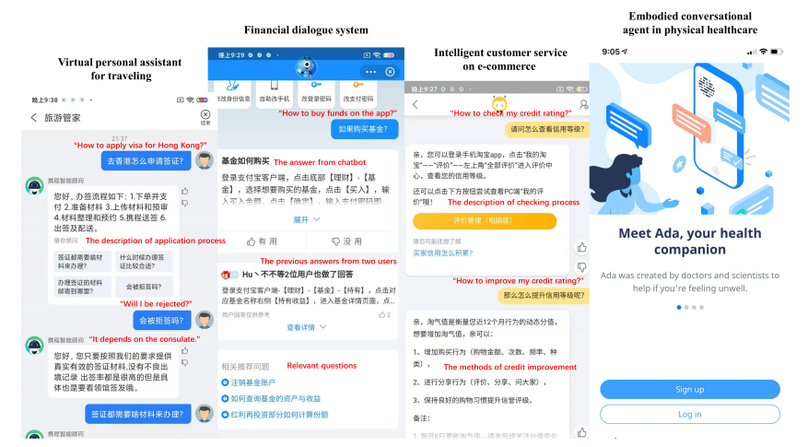

[5] It has been claimed that Cui created the virtual assistant bot for the e-commerce name SuperAgent to provide product information and list the services. In 2018, Xuel upgraded the bot's response by extracting data from customer's intentions. Xuel and Cui have created a new chatbot ISA(Intuit Smart Agent) that collects a large amount of data from the answer and previous chats to create high-quality responses to customers(Cui et al. (2017); Xuel et al (2018)). Furthermore, new features such as negotiation, suggestion and emotion were also integrated into the chatbot (Kuramoto et al., 2018).

Kimani et al. (2019) created an RNN-based chatbot named Amber, which uses a sensing framework to generate responses. It auto-created timetables for workers, prioritised tasks, set reminders,…

Regarding the financial technology industry, many banks have applied chatbots to take advice and manage the risk when introducing new products and services. (Beketov et el,. 2018). Okuda and Shoda (2018) created the Finplex Robot Agent Platform, a chatbot that improves the sales of products and services.

Moving to healthcare, chatbots have been applied to diagnose diseases through patients' symptoms. Van Heeren et al.(2017) created a chatbot that gives instructions to patients before the HIV tests. The chatbot has high security in protecting patients' information, so patients always entrust their privacy. Furthermore, some ECAs can analyse the patient's symptoms and provide available treatment. These bots can store large amounts of data and processing in a second. Moreover, the chatbot can also work as a health manager to guide people in protecting themselves from and avoiding diseases.

Regarding the pedagogical, chatbots have been applied as the primary communication tools for learners. Heristiani et, al (2019) created Gengbot based on Japanese grammar and English annotation, which helps students learn vocabulary—due to shortness of skilful teachers to teach programming language, Pérez-Maríns and Boza(2013) created a bot instruct exercise in physics and chemistry. The bot will increase the difficulty of the questions if the students answer correctly and give guidance or instruction to solve the problem students answer incorrectly.

# **Artificial intelligence and Machine Learning**

**Artificial intelligence technologies:**

Artificial intelligence can do various human tasks by mimicking human behaviour based on the uploaded database and specialised algorithm technologies like Machine Learning to analyse a big chunk of information and make predictions about the future. Moreover, they can access directly to the internet to give the requested information to the users.

Currently there are two main different levels of AI: [15]

* Narrow AI: small to medium Artificial Intelligence model that trains to do specific tasks or requested assignments based on existing data which can be used to analyse and predict the solution. For instance, Apple Siri and Google Assistant are narrow AI.
* General AI: also known as strong AI, in theory, they could have the cognitive ability and critical thinking like a human being independently, AGI (artificial general intelligence) have the decision-making capability meaning they could find the solution of new problems autonomously. Currently, AI researchers have not got enough resources to achieve general AI.
* Super AI: The most advanced AI type with the capability beyond human understanding that has their own emotion, belief and faith needs. Therefore, theoretically they surpass human beings from critical thinking, learn ability and develop on their own.

**Purpose**

In real world applications, Artificial Intelligence has impacted deeply. Many brands have applied AI to respond whenever customers want to place an order without human interaction physically. This has sped up the process and prevented the bottleneck if there are large amounts of order simultaneously. Because of advanced algorithms the AI can also help in advising customers service in general concern and only use human resources in specialised work. Furthermore in present days Google has implemented AI in healthcare by scanning images of patients and can analyse and diagnose cancers, eye diseases. Artificial Intelligence can help with autonomous systems like self-driving cars and manufacturing chains. More significantly, AI can get updated and advanced each year with the information constantly uploaded to its database and trained model by human behaviour.

Recently, beside AI assistants, the release of ChatGPT (Generative Pre-trained Transformers) and Google Gemini which are generative AI meant they can generate creative products like paintings, articles and also small to medium sized programming code. They are a stronger and more advanced type of AI which can give answers directly to the users in human-like languages in the form of a chat box.

**How can it be improved?**

Machine learning is still in its early stages and has a lot of limitations. In existing days, AI still significantly relies on the current database and human training to behave suitably in real-life scenarios. For the next few years, It is ambitious to get AI to the next level as the technology is advancing rapidly. In the future, the hardware can involve faster GPUs (Graphic Processing Units), which can speed up the algorithm and train complex AI models to have the ability to analyse bigger data and predict more accurately, this also helps AI gain the human cognition to think and make decisions individually. This further improves the creativity and innovation of AI and can generate more distinctive and original ideas and content. General AI can be a potential self-learning program as it advances by acknowledging skill and information over time without human intervention, they can have the capacity to understand a wide range of specialised skills in order to assist humans effectively.

**What is the likely impact?**

Since the rapid development of technology, Artificial Intelligence can accomplish complicated tasks, which has raised various concerns about ethics and job replacement. The most recognized impact of AI is that the automation of industry can replace many low-value jobs, which are the most affected people, although this leaves human space for more creative jobs. However the impact of AI is not the same between different industries. For example, in the manufacturing industry, automation can replace workers on repetitive task chains that need synchronisation in each element which is less time-consuming and more efficient compared to the human workforce. In contrast, the healthcare industry not only improves performance but also provides more high-value jobs that need critical-thinking and empathy. [16]

**How will this affect you?**

From the perspective of a university student, the rapid development of Artificial Intelligence and Machine Learning can be a beneficial tool if we implement it in the right way. As I currently study in Information Technology bachelor, artificial intelligence can help the information search on the internet be a lot quicker instead of finding it manually. Furthermore, Artificial Intelligence can help newbies learn how to write basic code as the AI can explain each element function without looking up online. Because of that reason it is easier and faster to learn how to code, for senior developers they can let the AI code the short piece of basic codes that are repetitive and let them have time for the bigger problem requiring critical thinking which can speed up the software development process and workflow.

However, the AI also has a negative impact as the students implement it in the wrong way. There are minority groups of students who take advantage of AI to do their coding assignment for them to pass the course without learning it properly. Therefore many students who pass the course without actually having any coding experience could harm university credit. In conclusion, AI is a handy tool if we know how to apply it correctly and it is important to raise awareness of plagiarism and take advantage of AI before using it.

# 

# **Robots**

**What does robot do?**

Robots are machines that can perform tasks autonomously traditionally carried out by humans. The state of the art in robotics involves developed machines capable of complex movements, advanced perception, and decision-making abilities, from big, industrial robots performing material management, engineering tasks, and assembly and inspection to smaller robots engaging in social interactions and domestic household chores [17].

In manufacturing, starting from material management, robots are used for tasks like material transfer and machine loading and unloading. In material-transfer applications, robots are tasked with the movement of materials or work parts from one point to another. It ranges from simply picking up materials from one conveyor to more intricate tasks such as placing parts onto pallets, arranging them in a specific configuration calculated by the robot [18].

For engineering tasks, robots control tools to execute processes on workpieces. Examples of these applications encompass spot welding, continuous arc welding, and spray painting. For example, spot welding of automobile bodies, the robot process involves aligning a spot welder precisely against the panels and frames of an automobile, contributing to the final assembly of the foundational car body. In the case of arc welding, the robot engages in a continuous procedure, guiding the welding rod along the targeted seam for welding purposes. When it comes to spray painting, the robot manoeuvres a spray-painting gun across the object's surface, ensuring a thorough coating. Within this category, additional operations comprise grinding, polishing, and routing, wherein a rotating spindle assumes the role of the robot's tool [18].

When it comes to assembly and inspection, due to their programmable nature, a strategic approach in assembly involves producing diverse product styles in batches, reprogramming the robots between batches. Alternatively, a different tactic involves manufacturing a blend of various product styles within the same assembly cell. In this scenario, each robot within the cell is required to distinguish the arriving product style and subsequently carry out the appropriate task for that specific unit [18].

The product design plays a crucial role in the context of robotic assembly. There are tasks that are more suitable for human workers than robots. For instance, utilising a screw and nut as a fastening method, a task easily performed in manual assembly, poses significant challenges for a one-armed robot. Designs that incorporate components added from the same direction using snap fits and other one-step fastening procedures facilitate a more straightforward accomplishment of the work through automated and robotic assembly methods [18].

Inspection represents another expanding area within factory operations where robots find increasing utility. In a typical inspection task, the robot uses a sensor concerning the work part and assesses whether the part aligns with the quality specifications [18].

In the future, there will be advancements in technology. Enhanced artificial intelligence (AI) capabilities will enable robots to better understand and respond to their environments. This includes improved object recognition, natural language processing, and decision-making abilities. Additionally, we can expect more collaborative robots, or cobots, that work side by side with humans in shared spaces [19].

Technological developments driving these advancements include breakthroughs in AI, machine learning, computer vision, and sensor technologies. Progress in materials science also contributes to the development of more adaptable robotic systems.  
  
**What is the likely impact?**

The potential impact of robots on society is profound. In the workplace, robots have the potential to increase productivity, efficiency, and cost-effectiveness but may also replace certain jobs, especially those involving repetitive and routine tasks. Industries like manufacturing, agriculture, healthcare, and transportation are likely to see significant transformations, leading to the creation of new jobs that require human oversight and technical expertise [20].

Manual workers of lower and middle class, especially in manufacturing industry will be the most affected due to the usage of fully autonomous robots that don’t require human operators. With robots, they can do the work of 6 workers in a degree, which improves efficiency by an amount [21].

In terms of daily life, robots may become integral in areas such as household chores, healthcare assistance, and elder care. This could alleviate the burden on individuals and families while providing support for an ageing population [22]. However, ethical considerations regarding privacy, security, and the potential for misuse will need careful attention.

**How will this affect you?**

In my daily life, the impact of robots could manifest in various ways. Smart home devices and domestic robots such as Roomba for vacuum cleaning handling routine tasks, making my life more convenient. However, adapting to these technologies may require continuous learning and understanding of how to integrate them into daily routines and how to do repair and ensure the maintenance for long term usage.

For friends and family, the impact could be felt in terms of job opportunities and skill requirements. Those in industries susceptible to automation might need to undergo retraining or seek new employment opportunities. Also, the introduction of robots in healthcare such as surgery robots or therapeutic robots [23] could enhance the quality of medical services but may also raise ethical concerns.

In summary, the advent of robots represents a transformative technological shift with both positive and challenging implications for society. Balancing the potential benefits with ethical considerations and addressing the impact on the workforce will be crucial for ensuring a positive outcome from the integration of robots into various aspects of our lives.

# 

# **4. Project Ideas:**

## **Overview:**

Our project, Polymage is intended to be a public website and a mobile app that act as a repository for 3D artists, animators and other visitors to view, sell and buy, upload and download 3D models. The idea for Polymage is that it is an online platform for creative and artistic individuals to be able to exchange ideas and download 3D assets the way they want that can be used for simulations, animated films or video games. The site will also feature a market for selling user-made 3D assets, a community portal and forums for creators (animators and artists) with accounts to provide feedback for the platform, share their works and even get to have their works be featured on the front page of the site.

Polymage will also incorporate a WebGL-based interactive 3D viewer that can also be embedded into other websites and online-based platforms such as Discord, Facebook, Wix, Twitter and Artstation. Therefore the platform would also be very helpful for users who are professional 3D artists, animators, or tutors and students who need 3D assets and renders as teaching materials and references for their projects in regard to the field of graphic design, animation and game design.

## **Motivation:**

Due to the lack of graphic interactive platforms where people can share and discuss. We believe PolyMage can solve this problem, it is a place where users can post their art or graphical simulations for trading purposes, it is also a place where people can communicate with each other about their products for comparison between their designs which will give them ideas on how to improve their designs. This can be a great place for people who want to aim to become a graphic designer and it can be used to serve for education purposes. We are glad to support educational organisations with the help of experts in the field in order to provide learners with reliable and necessary material that helps them in their study period.

## **Description:**

In this part, we will describe our product in a general way of how our program is supposed to look and how it functions. This may not cover everything in our software, but it will give you enough details about it.

The platform has a collapsable menu on the top left, users can click on it and then select to the area they want to go, the menu contains: Graphic Testing Simulation, Trade Market, User Chat Box, User Support Request.

Graphic Testing Simulation section provides a terminal hub where people can test out the result whenever there is a graphic art or simulation that needs to be tested, it will also provide a suggestion list based on the same environment from the system collection. Therefore, people could have a clearer look of the surroundings inside of their product, they can add something they wanted to make it look better with the help of our default graphic tools or extensions tools pack (Must be chosen in the tools reference section in the terminal).

  Trade Market is a section where people can upload their products to sell it or to buy one if they want to have it, price can be negotiated between two users. Here, it will display every product of every user that published it. Customers who want to have a specific art design can use the search engine to sort out the area they want to see by clicking the search icon, there it will have a clickable panel, a panel name as “categories” which is to select the tag they want to add in, to find the design easier. Once they give out enough details and click the search panel. The system will then process to search out every possible product that matches with the customer's description given.

When users access the User Chat Box by clicking it in the menu, they will be switched into a direct messaging chat platform, where they can communicate with other people in a group by searching their name or with people who are already their friends. To send a friend request, people have to go to the Friend Request Section in the central top right. When they click on it, it will also have a clickable panel where they click on it and type out user ID or username of someone's account and then click the enter to send the request.

In User Support Request, where users send a ticket there will be an Administration team to get support from them when there is something that they are unsure about or there is a problem. Users will get support by the Administration Team in 24 Hours, they will advise or solve customers problems. To submit a request, there is a typeable board where they will write out what they want to know and then submit it by clicking the submit button or clicking Enter.

## **Tools and Technology:**

Polymage implements webGL (web Graphic Library) which is Java Script API (Application Programming Interface) to display the 3D models and 2D textures that users upload. In addition, users can also add the Polymage third-party plugin to 3D modelling programs such as Maya, 3DS Max, Blender to upload directly to the online repository and share it publicly. In backend use Java makes website features like sorting system, search engine and input user file. For faster user experience, 3D model files will be stored in our cloud server so users can access and view models effortlessly without making their device load it locally.

## 

## **Skills Required:**

For most of the web UI/UX (User Interface/User Experience) front end will use HTML to display web page content combined with the CSS to format the page layout. This means we need to be proficient in those languages. Also since the platform is WebGL-based, understanding of JavaScript is also needed to write programming for interactive 3D viewers that can be used to display and render the models, textures and environments.

## **Outcome:**

Our team created the Polymage program with the aim of:

Support users in creating 3D images and create an environment for online users to interact, share and trade online about their projects with others. The software will help the primary user illustrate better when they explain the details of their project in the presentation with clients or teammates, and the participants will have a clear image of the product. This will be more convenient to the user than using two corresponding software programs to represent the idea. Furthermore, the project host can allow other sub-users to interact with the product when required to error test it.

# **Feedback:**

Tran Minh Kiet - s3979253

Your ideas are great, but who could be the stakeholders of this project?. How much time and the cost would it take to push this project out for the world (approx.)? What’s the difference between this and NFTs?

Answer: The stakeholders for this project will be big video game publishers or distributors like Valve, Tencent or NEXON, because the site is supposed to be a platform for 3D VR and AR contents for all users to publish, share, discover, buy and sell their assets. It is not NFT because these are not blockchain technology, and also this website/mobile app project has more to do with game development, simulation and 3D animation fields because the 3D assets that will be hosted on this site are for these IT sectors.

Tran Phan Hoang Phuc - s3929597

Is there a chance of someone illegally downloading the product from someone and posting it somewhere else?. Is there a way for users to check out the product of someone who is not misleading?

Answer: This is a very recurring problem with websites that allow the sharing and downloading of free contents. One of the ways we intend to implement is to have an AI-based detection mechanism that can analyse the contents on whether they are ripped/extracted game contents from other pre-existing publishers or developers. After that we also have a number of moderators on the site to peer review again to see whether the contents actually violated the rules regarding IP copyrights. Furthermore, the marketplace for the 3D assets will have some forms of regulation regarding uploaded contents and if the uploaders violated potential IP infringements, said contents will be taken down and the account that uploaded it will be banned permanently.

We would like to thank you for the feedback. So far they have been very helpful for us to explain the details of our project much better. Also regarding the copyright problem, this is a very grey area so while we do intend to have the site as a free for all 3D asset repository, monetization of pre-existing IPs are definitely not something we tolerate as it could lead to copyright infringement. Once more I would like to stretch that, this is not NFT technology as we do not use block chain, but instead, this site is a place for host, share, view, buy and download 3D assets for game development, animation, AR and VR simulations as well as the related educational fields for students and teachers.

# **References:**

[1] Environmental Protection Agency, “Self-driving Vehicles”, EPA, 2023. <https://www.epa.gov/greenvehicles/self-driving-vehicles> (accessed Dec 12, 2023).

[2] Encyclopedia Britannica , “Autonomous Vehicle”, Britannica, 2023.

<https://www.britannica.com/technology/autonomous-vehicle> (accessed Dec 12, 2023).

[3] National Highway Traffic Safety Administration, ”Automated Vehicles for Safety”, NHTSA, 2023.

<https://www.nhtsa.gov/technology-innovation/automated-vehicles-safety> (accessed Dec 12, 2023).

[4] Remington.T, Ellis.T, “Forget Working From Home, Autonomous Vehicles Will Drive A Boom In Working From Car”, Forbes, 2018.

<https://www.forbes.com/sites/ellistalton/2018/08/20/forget-working-from-home-autonomous-vehicles-will-drive-a-boom-in-working-from-car/?sh=6792d0ed5904> (accessed Dec 12, 2023).

[5] O. V. Deryugina, "Chatterbots," *Scientific and Technical Information Processing,* vol. 37, no. 2, pp. 143-147, 2010, doi: 10.3103/s0147688210020097.

[6] B. Luo, R. Y. K. Lau, C. Li, and Y. W. Si, "A critical review of state‐of‐the‐art chatbot designs and applications," *WIREs Data Mining and Knowledge Discovery,* vol. 12, no. 1, 2021, doi: 10.1002/widm.1434.

[7] J. A. Moldt, T. Festl-Wietek, A. Madany Mamlouk, K. Nieselt, W. Fuhl, and A. Herrmann-Werner, "Chatbots for future docs: exploring medical students' attitudes and knowledge towards artificial intelligence and medical chatbots," *Med Educ Online,* vol. 28, no. 1, p. 2182659, Dec 2023, doi: 10.1080/10872981.2023.2182659.

<https://www.ncbi.nlm.nih.gov/pubmed/36855245>

[9] Microsoft Azure, “What is a VPN?”, Azure, 2023  
<https://azure.microsoft.com/en-us/resources/cloud-computing-dictionary/what-is-vpn> (Accessed Dec 14, 2023)

[10] NordVPN, “What is a VPN”, NordVPN, 2023

<https://nordvpn.com/what-is-a-vpn/> (Accessed Dec 14, 2023)

[11] Norton, “10 benefits of a VPN you might not know about”, Asia Norton, 2023

<https://asia.norton.com/blog/privacy/benefits-of-vpn> (Accessed Dec 14, 2023)

[12] Discover Magazine, “How VPN is Changing the Way we Use Internet”, Discover Magazine, 2023

<https://www.discovermagazine.com/sponsored/how-vpn-is-changing-the-way-we-use-internet> (Accessed Dec, 14 2023)

[13] CBS News. “What's a VPN, and why should you use one?”, CBS News, 2023

<https://www.cbsnews.com/essentials/what-is-a-vpn-and-why-should-i-use-it/> (Accessed Dec 15, 2023)

[14] NordVPN, “Artificial intelligence in cybersecurity: Pros and cons”, 2023

<https://nordvpn.com/blog/artificial-intelligence-in-cyber-security/> (Accessed Dec 15, 2023)

[15] IBM, “Understanding of different types of artificial intelligence”, IBM, 2023

<https://www.ibm.com/blog/understanding-the-different-types-of-artificial-intelligence/> (Accessed Dec 14, 2023)

[16] Linkedin, “The impact of artificial intelligence on Society”, Linkedin, 2023

<https://www.linkedin.com/pulse/impact-artificial-intelligence-society-opportunities-challenges-sen#:~:text=In%20conclusion%2C%20the%20impact%20of,potential%20for%20misuse%20or%20abuse>. (Accessed Dec 15, 2023)

[17] Encyclopedia Britannica , “robot (technology)”, Britannica, 2023.

<https://www.britannica.com/technology/robot-technology>(Accessed Dec 15, 2023)

[18] Encyclopedia Britannica , “Robots in manufacturing”, Britannica, 2023.

<https://www.britannica.com/technology/automation/Robots-in-manufacturing>(Accessed Dec 15, 2023)

[19] M. Soori, B. Arezoo, R. Dastres. “Artificial intelligence, machine learning and deep learning in advanced robotics, a review.” [*Cognitive Robotics*](https://www.sciencedirect.com/journal/cognitive-robotics), vol. 3, p. 62

<https://www.sciencedirect.com/science/article/pii/S2667241323000113> (Accessed Dec 15, 2023)

[20] Linkedin, “Revolutionizing Industries: The Advancements and Impact of Robotics and Automation”, Linkedin, 2023

<https://www.linkedin.com/pulse/revolutionizing-industries-advancements-impact-robotics-zakaria> (Accessed Dec 15, 2023)

[21] [S. Brown](https://mitsloan.mit.edu/ideas-made-to-matter/sara-brown), “Forget Working From Home, Autonomous Vehicles Will Drive A Boom In Working From Car”, MIT Sloan School of Management, 2020.

<https://mitsloan.mit.edu/ideas-made-to-matter/a-new-study-measures-actual-impact-robots-jobs-its-significant> (Accessed Dec 15, 2023)

[22] E. G. Christoforou, S. Avgousti, N. Ramdani, C. Novales and Andreas S. Panayides “The Upcoming Role for Nursing and Assistive Robotics: Opportunities and Challenges Ahead.” *Front Digit Health*, vol. 2, p. 585656, doi: 10.3389/fdgth.2020.585656

<https://www.ncbi.nlm.nih.gov/pmc/articles/PMC8521866/> (Accessed Dec 15, 2023)

[23] Case Western Reserve University, “Medical Robots Making a Difference in Healthcare”, Case Western Reserve University, 2017

<https://online-engineering.case.edu/blog/medical-robots-making-a-difference> (Accessed Dec 15, 2023)

# 

# **Appendix:**

**[1] This will display all members tests:**

**Le Huy Hoang**

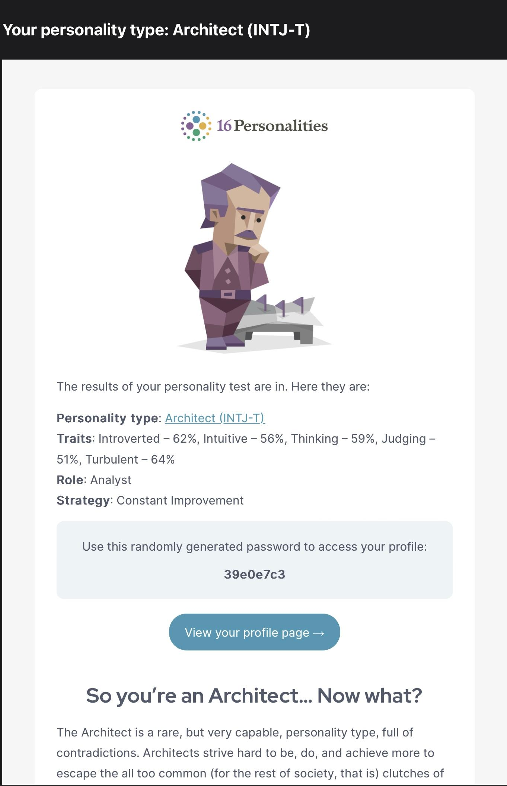

## 

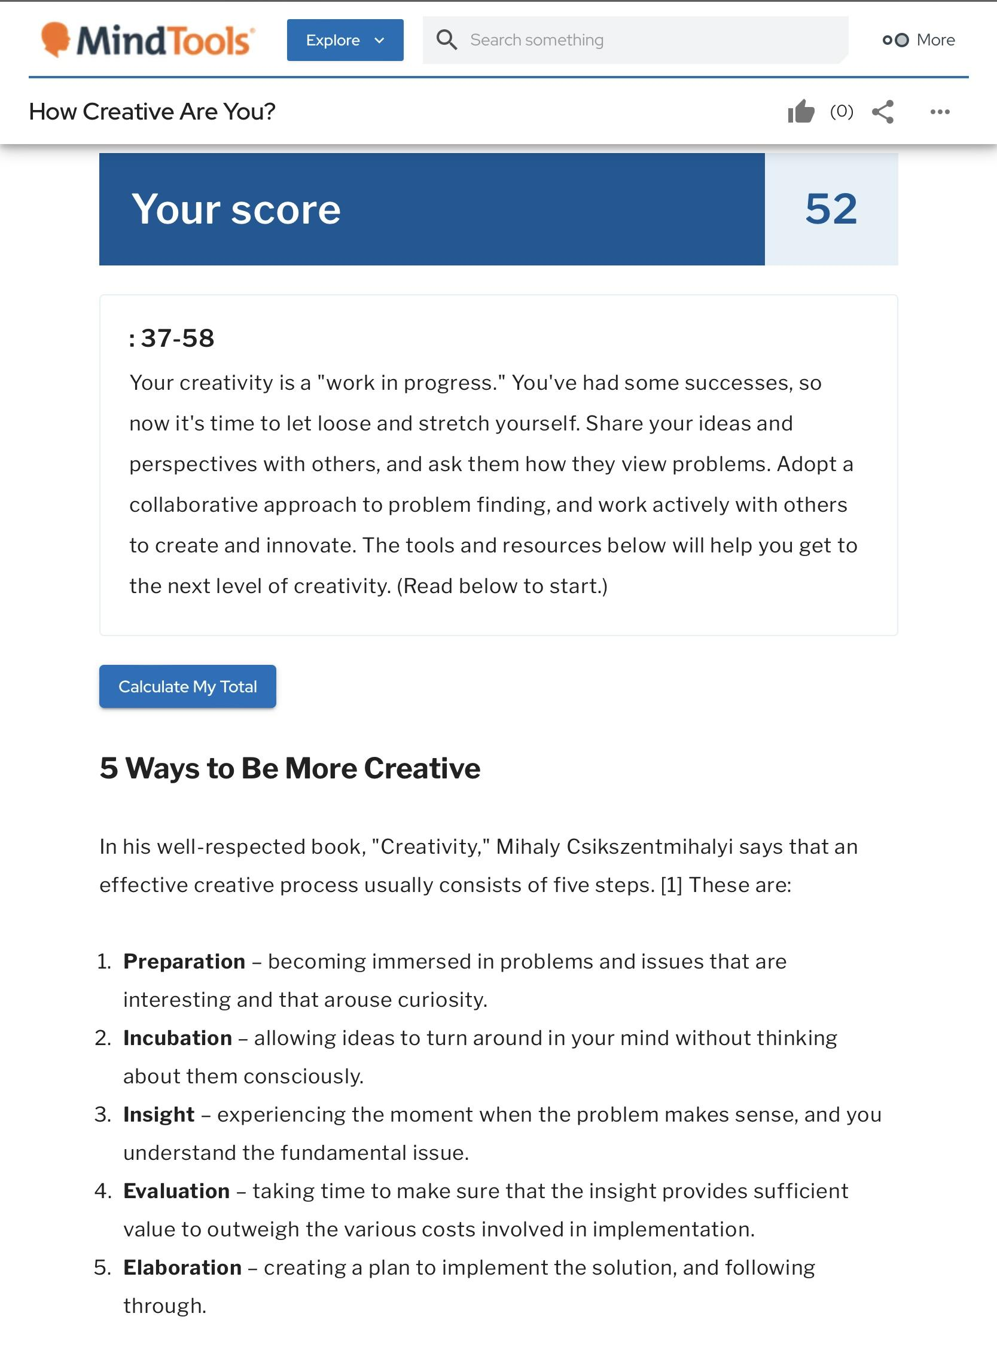

**Tram Anh Tuan**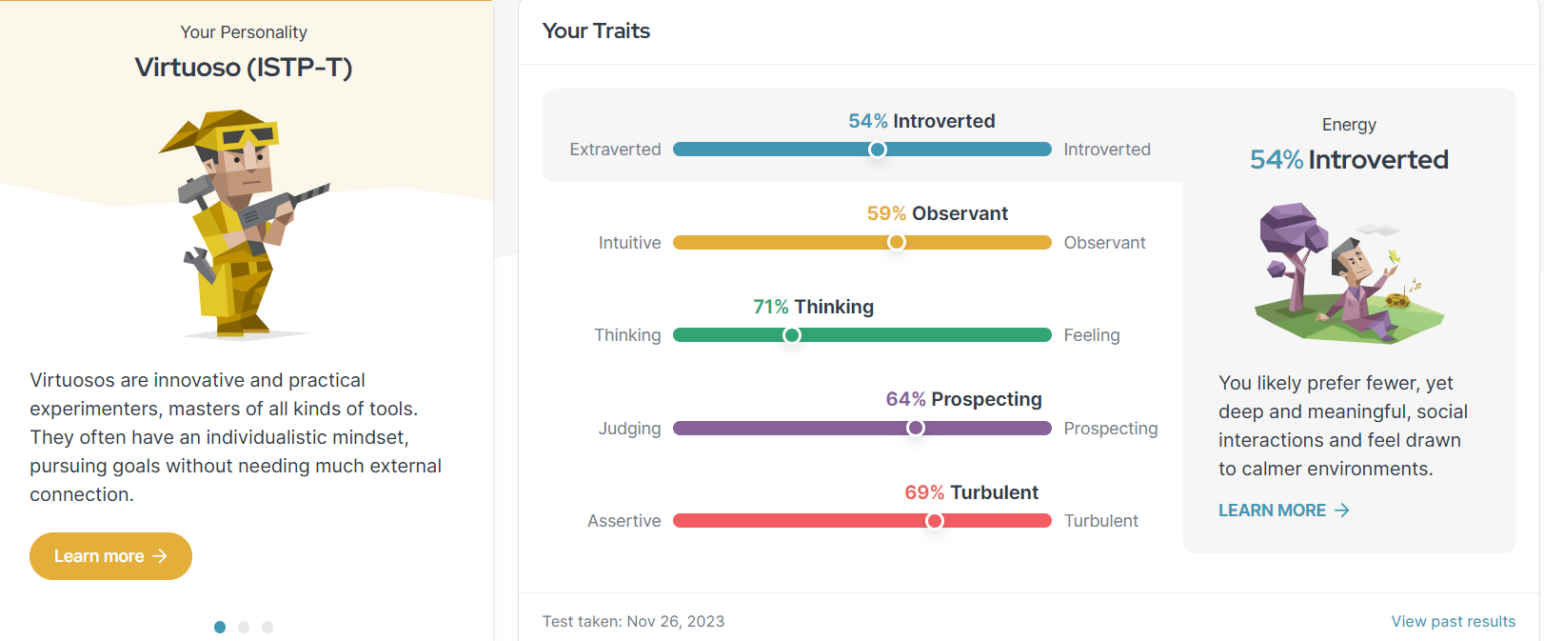

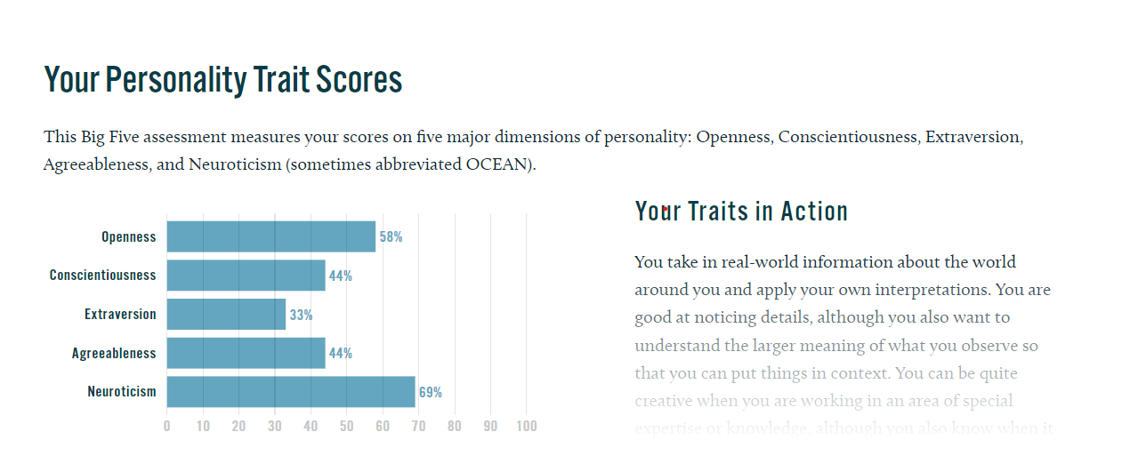

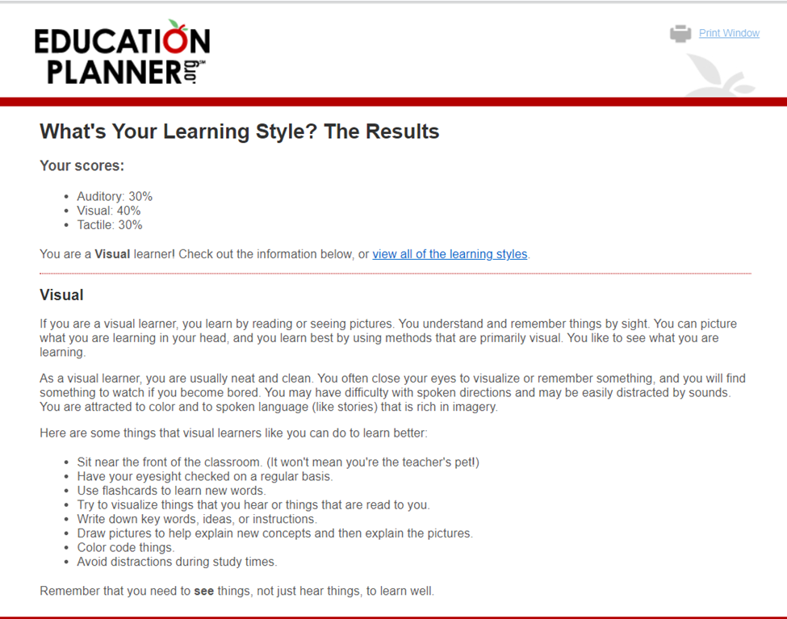

**Nguyen Luong Le Bao**

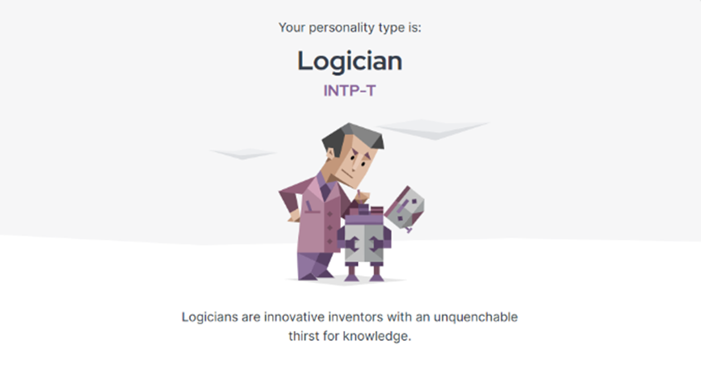

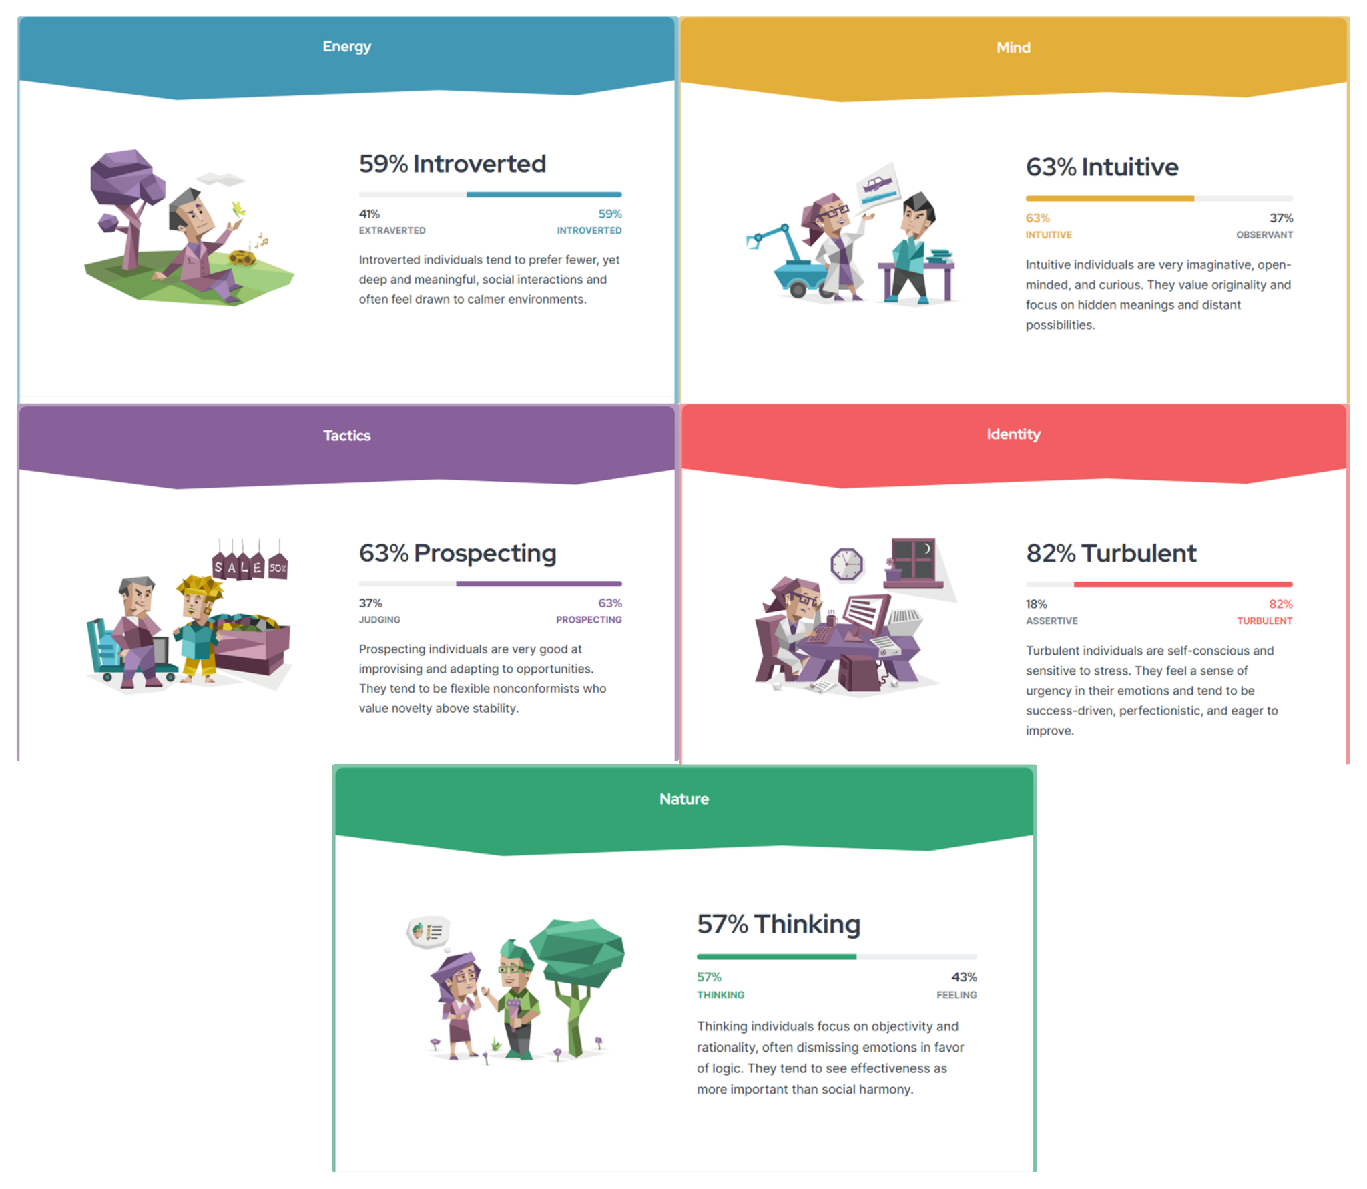

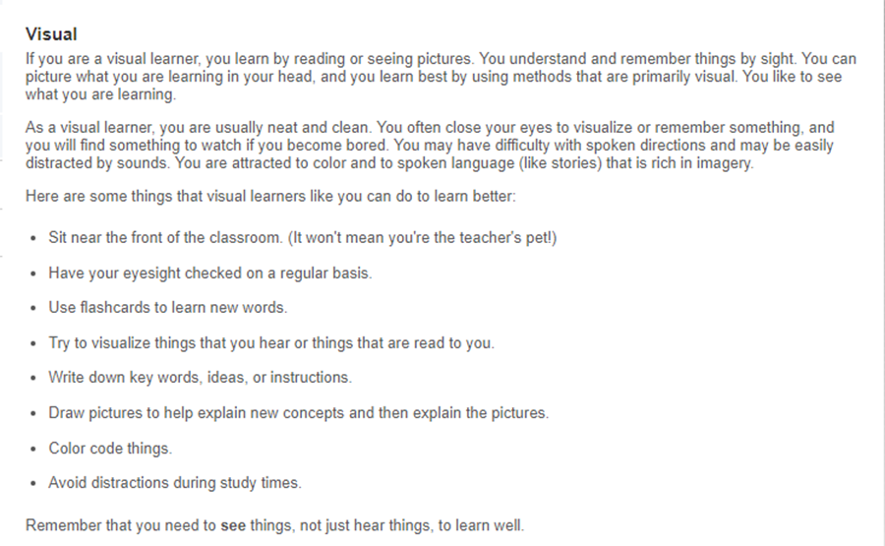

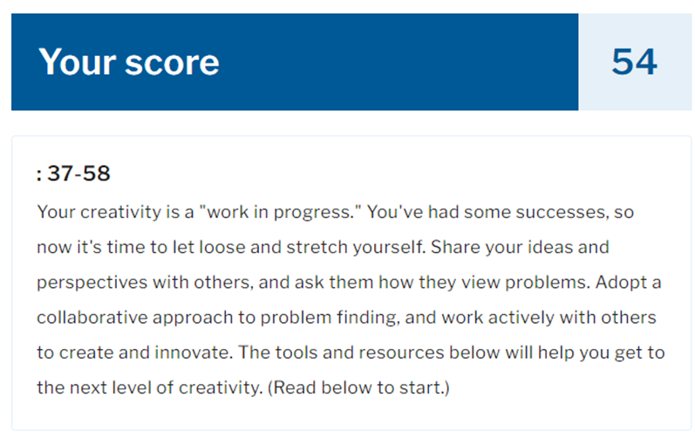

**Nguyen Viet Hoang Dan**

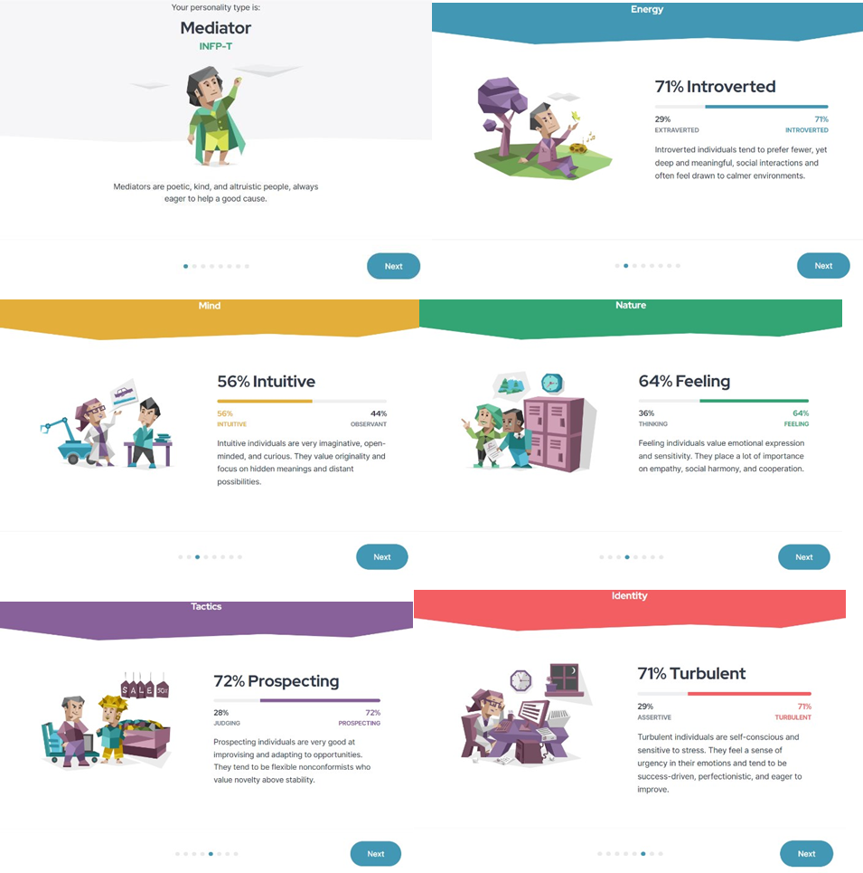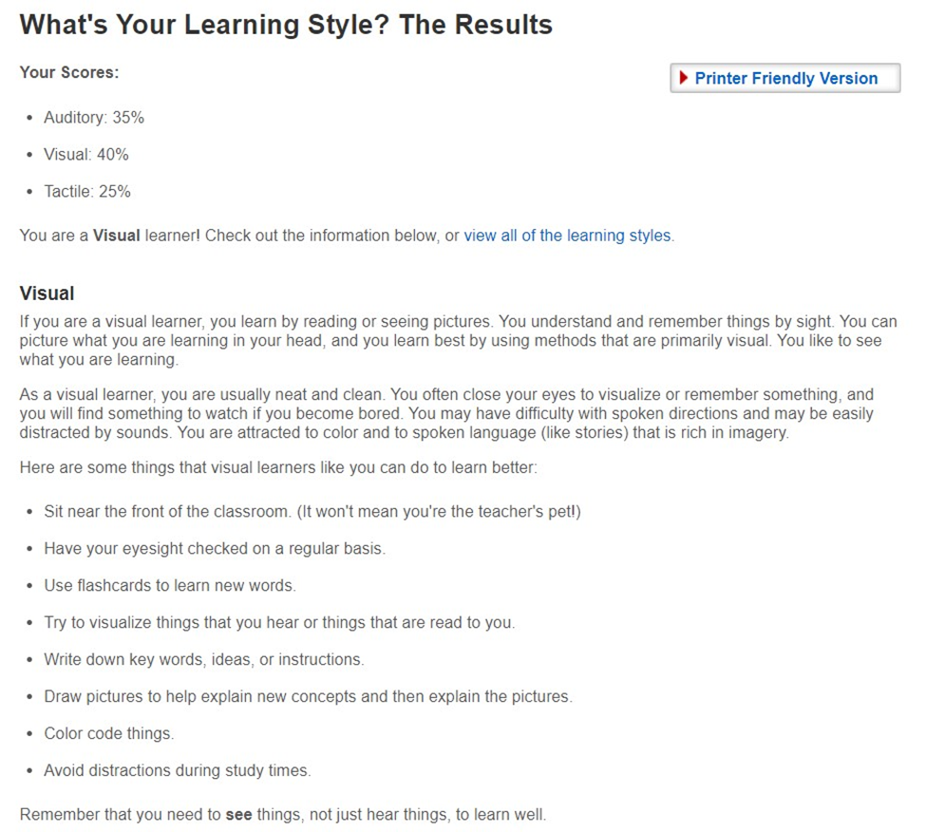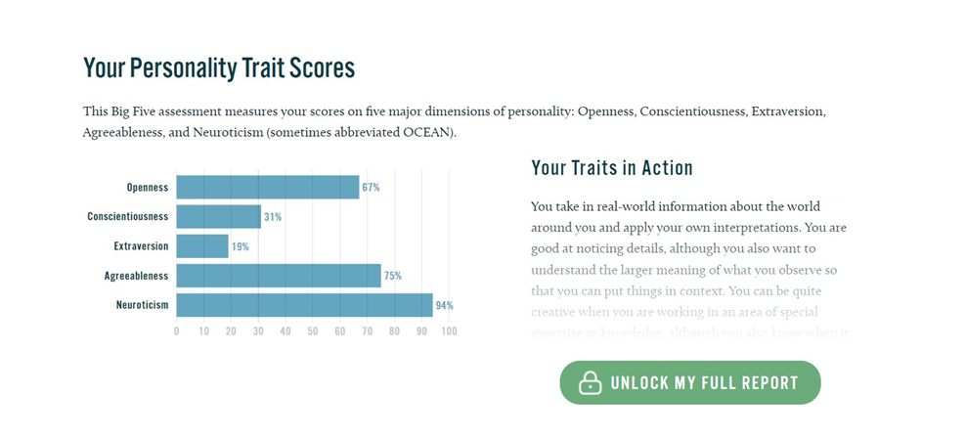**Do Le Minh Quan**

